Instruction Manual
&
Warranty Card

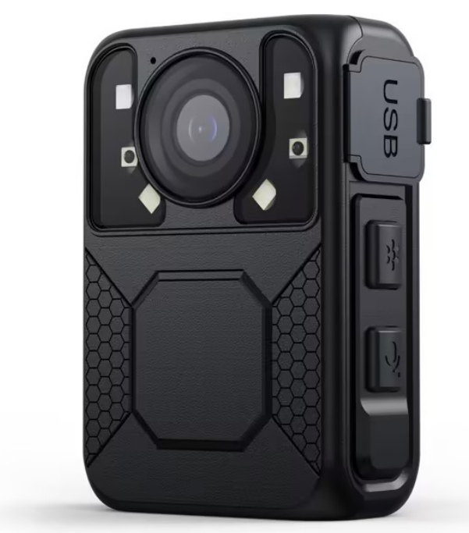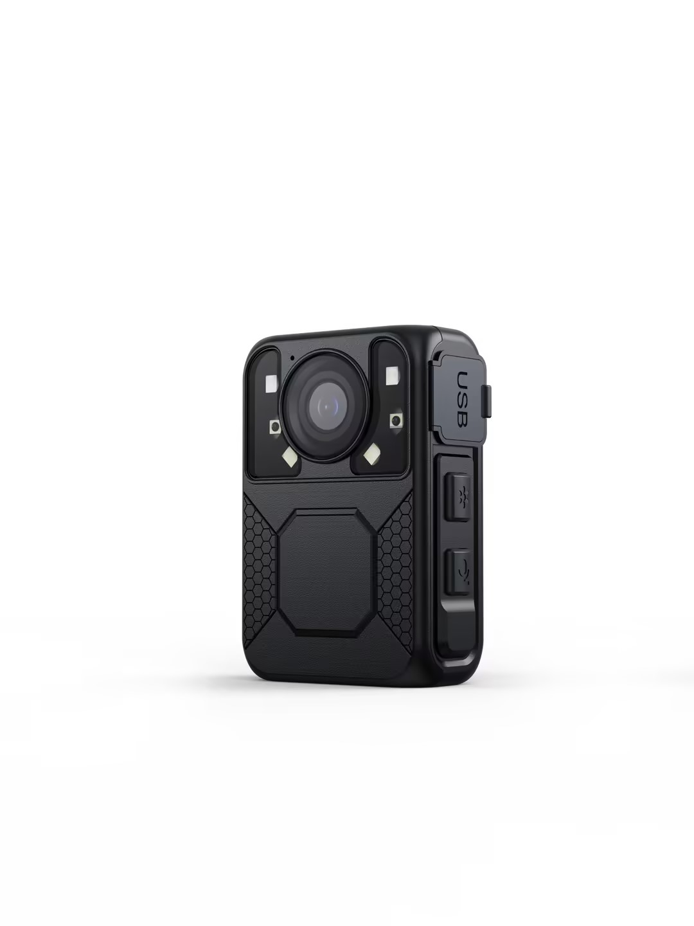
Video Law Enforcement Recorder
Video output | Type-C
Photo Format | JPEG
Pre recording time | Up to 30 seconds
Time of delay | Up to 1 minute
Quality of video | Best/quality/standard
Segmented time | 5min/10min/15min
Watermark | User ID,Time and Date Stamp (and GPS)
Camera | 2 million camera
snapshot | Supports capturing photos during video shooting
Memory capacity | 32G /64G/128G/256G
One click recording | Supports one-click recording
Infrared light Switch | Automatic/Manual
display screen | 1.6-inch TFT-LCD HD display
Video camera
Angle of view | Wide Angle 140°
Night vision shooting | Support -- Built-in four high-intensity infrared lighting systems;You can see faces from 10 meters away
Clip | High quality 360° rotating metal clip
Battery
Type | Standard 3.8V lithium-ion polymer battery 2350mAh
Charge duration | 4H
Time of use | Working 10 hours at 720P
Other
Specifications | 70mm*47mm*26mm
Class of protection | IP65 waterproof/dust-proof / 3-meter fall proof
Weight | 99g（5.64oz）

Project | Parameters
Video
Sensor | GC2053 2Mega CMOS
Chipset | Lianyong NT96672
Pixel Size | 4032×3024(12M)/3648×2736(10M)/  3264×2448(8M)/2592×1944(5M)/  2048×1536(3M)/640×480(VGA)
Resolution of video | 2304×1296/1920×1080/1280×720/848x480
Video Format | MP4 H.264&H.265
Fast forward backwards | 2X, 4X, 8X,16X
Audio format | WAV
01
2.Parameters

The single police audio and video law enforcement recorder developed by our company contains a number of latest positioning and audio and video processing technologies, with comprehensive functions and reliable performance. Law enforcement officers use the equipment in law enforcement on-site missions to record in real time, collect evidence, standardize law enforcement, and truthfully document the enforcement process to ensure more accurate and fair enforcement.
。
1.Introduction

02
Preface

Thank you for choosing the single police audio and video law enforcement
recorder. I hope that our products can
Contribute to your hard work of law
enforcement!

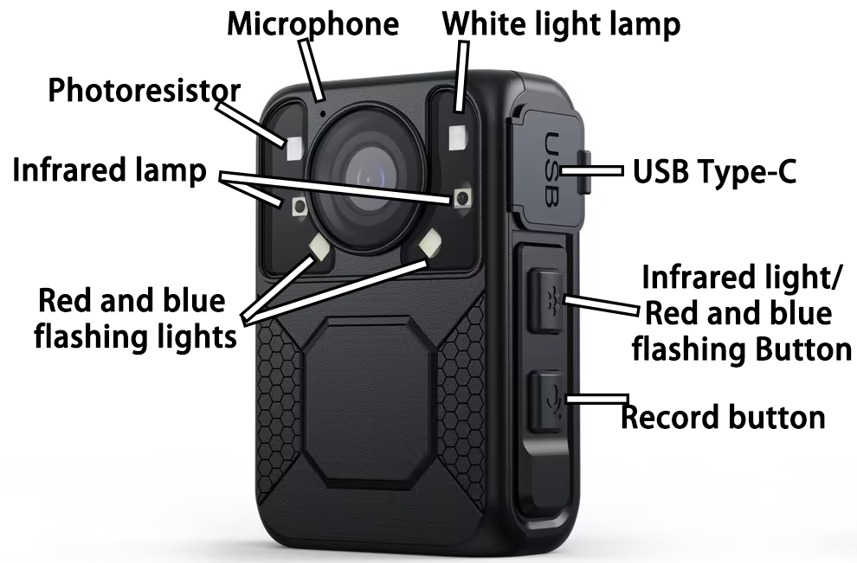
4.Key Description
3.Operation Instructions
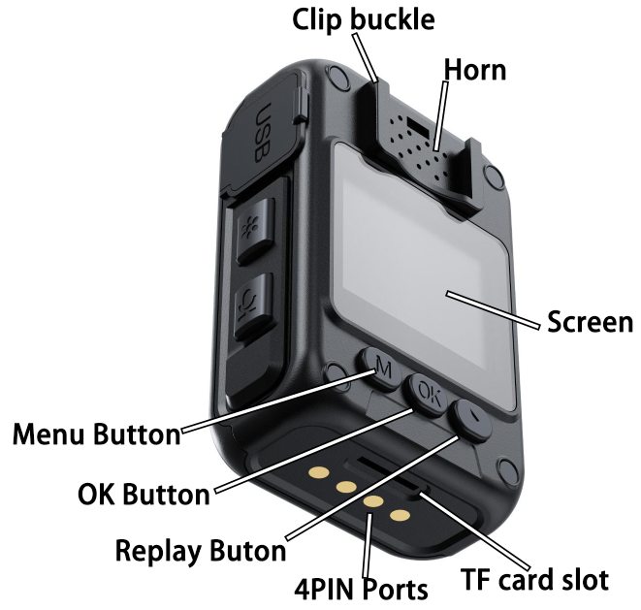

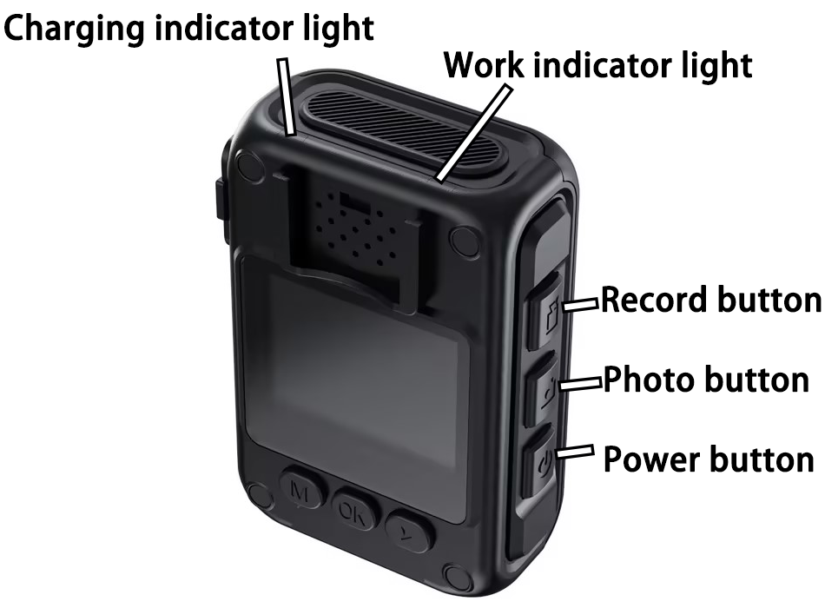
Press the switch on and Off buttonStart up and enter the standby screen.
Press the "Recording Function" key  Start recording.
Press the [Photo] button  Take pictures.
Long Press the [Photo] button Turn on the WIFI.
Press the Camera button  Video recording.
Press the 【Play】 key  Enter the video, photo and recording folders respectively to select audio and video materials and select confirm before playing.
Short press【Menu】 can set the functions and parameters of the machine.
Press【Switch】 can return to the previous interface.
Short press the  button to turn on the white light, long press to turn on the red and blue flashing lights.
04
03
03
04
- Power On
Power On：Press【Power On】for two seconds，prompting sound，
the green standby indicator lights up and the screen enters the
real-time monitoring standby state.
- Voice Recording 
In real-time monitoring standby mode. Short press 【 voice
recording 】, fuselage vibration, yellow recording indicator
Flashes, then start recording, press【voice recording】again,
stop recording , fuselage vibration, yellow recording indicator is
Off, recording saved.
- Camera
Monitor the standby status in real time. Short press the【Camera】, shoot and save photos.
- Video recording
Monitor standby status in real time, Short press the 【 Video
recording】, Red indicator flashes, means start recording, press【 Video recording 】again, stop recording, Red indicator is off, the recording ends and has been saved.
- One-click Video recording
During the power off state, press and hold the 【Video recording】(about 4 seconds) to directly enter the recording work state.
- Zoom
In real-time monitoring of standby status and recording process,
In the real-time monitoring standby screen,short press the 【One-
click playback】 to quickly play back the audio and video files of
the last operation record.press and hold【 Up navigation key 】or【 Next navigation button 】, can achieve adjustment
of focal length.
- Take a photo in the recording video status
In the recording status, short press the 【 Camera 】 once, can
capture and save a photo, the recording status is not interrupted.
- Infrared night vision light switch
Real-time monitoring in standby mode or during recording, Short
press【OK】once, turn on the infrared night vision light, press the【OK】again, turns off the infrared night vision light. When the infrared night vision light is turned on, it can meet the shooting needs in the dark night environment.
- LED white light
Short press the button to turn on the LED white light, and short press again to turn off the LED white light. Long press the button to turn on the red and blue flash function, and long press again to turn it off.
..

5.Basic Operation Instructions
06
05
- Fast forward and Rewind
In the local playback state，short press【Up navigation key】or【Next navigation button】, fast forward or rewind 2x, 4x,8x when playing video, for fast retrieval.
- Menu selection
When monitoring the standby screen in real time, press the
[Menu] to set the machine functions and parameters as
follows:

- Video resolution: Adjust the video resolution of the machine, press the "OK" key to confirm, and press the "Up Browse" or "down browse" key to select.

- Photo size: The picture quality and definition of the photos taken by the machine can be selected, which are VGA, 3M, 5M, 8M, 10M, 12M. Press the OK key to confirm, and press [Up Browse] or [Down Browse] to select.

- Video quality: Adjust the picture quality of the video shot by the machine, which can be divided into three modes: high quality, standard and economy. Press the "OK OK" key to confirm, and press the "Up Browse" or "Down browse" key for selection.

- Video pre-recording: After selecting open, you can record and save

more than 5 seconds of video data in advance before pressing the video key to start recording.

- Video delay: After selecting open, you can press the video key to stop recording, and then delay and save the video data of ≥5 seconds.

6) Circular recording: When the capacity of the video is full, the earliest video file will be automatically deleted and the current video file will be stored.

7) Recording time: the video file of the machine is segmented to select five modes of 5, 10, 15 minutes respectively. Press the "OK" key to confirm, and press the "Up Browse" or "Down browse" key for selection.

8) Infrared switch: manual and automatic switch can be selected.

9) Motion detection: After selecting Open, when there is an object moving in the picture, the recording will be automatically started until there is no object moving in the picture.

10) Screen saver: The screen saver can be closed, 1 minute, 3 minutes, 5 minutes, 10 minutes. Press the "OK" key to confirm, and press the "Up Browse" or "down browse" key to select.
07
08
- Date/Time: The date and time of the machine can be modified.

- Default Settings: Initialize the machine's Settings.

- Version: Check the current version number of the machine.

13. Connect the terminal (PC) to the device
When the terminal is connected to the device, you need to enter the password to read the device disk. After the device is connected to the terminal, click on the device six times until the password is entered, the terminal can read the device disk.

11) Automatic shutdown: Support off, 1 minute, 3 minutes, 5 minutes, 10 minutes mode, short press the "OK" key to confirm, short press the "up browse" or "down browse" key for selection.

12) Indicator: The indicator can be turned on and off.

13) Key sound: Open and close the selection of the machine's key sound.

14) Video encoding: H.264 and H.265 are optional.

- Video audio: You can choose to turn on or off the audio of the audio of the video.
16）Date label: Optional on/off video watermark.

17）Vehicle mode: Select open, the machine will automatically record after the USB is inserted, and automatically stop recording after the USB is removed.

18）Vibration reminder: optional on/off vibration.

- Change password: When password protection is enabled, you can change the password.

- Password protection: After selecting Open, enter the menu and enter the U disk mode when you need to enter the password.
25) Police Constable number: The Police Constable number can be modified.

26) Device ID: The device ID can be changed.

10
09
6.Function Description
6. OK confirm button 
● Confirm the operation function;
● Manually switch infrared.
8. Recording function button
● Press this key to start recording, and press this key again to finish recording;
9. Photo function button
● Short press this key to take photos;
● Long press [Photo button] (about 4 seconds) to turn on the WIFI(AP).
10. Video function key
● Press this key to start recording, and press this key again to finish.
11. Menu/Browse button
● Press this key to enter the system setting interface; Press this key to select objects to adjust down or right while browsing files.
● In addition, this key has the function of adjusting the focal length. Long press this key to adjust the focal length in the standby monitoring screen and video; When playing a video, press this key for 2x, 4x, 8x,16x.

- Standby indicator
This indicator is green. When the standby state is monitored in real time, it turns on.
- The charging indicator
light is red when charging, and green when fully charged.
- Video indicator Red indicator
When recording, this indicator blinks.
4. Recording indicator
Yellow indicator, when recording, the indicator blinks.
5, the browse button
● Press this key to enter the video, photo, recording file browsing mode, and confirm the operation function;
● Enter the menu mode, press this key in the menu to achieve up or left to adjust the selection of objects;
● This key has the function of adjusting the focal length. Long press this key to adjust the focal length in the standby monitoring picture and video. When playing video, press this key to x2, x4, x8 fast forward.

12
11

12. White light, red and blue flashing lights
● Short press to turn on the white light, press again to turn off the white light;
● Long press this button (about 4 seconds) to activate the red and blue flashing function, and long press again to turn off the red and blue flashing lights.

13. USB interface
This interface can be connected to a computer to read machine data and provide charging functions.

14. Power on/off/lock screen button/return button
● When in shutdown mode, long press this button to turn on the device. When in standby or recording mode, long press this button to turn off the device.
Short press this button in standby or working mode to turn off the screen, and then short press it again to turn on the screen.
● In the system settings interface, short press this key to return to the previous option.

13
14
15
16
17
18
20
19
13
14
13
14
16
15
17
18
19
20

